Comparing Toroidal Transformer Types for Technical Specification: Open, Partially Encapsulated, Fully Encapsulated

Toroidal transformers are valued across industrial and OEM applications for their compactness, low stray magnetic fields, and high efficiency. However, the choice between different types, particularly open, partially encapsulated, and fully encapsulated REO Types, RFT-O, RFT-MV, and RFT-VV, respectively, has significant implications for mechanical integration, thermal management, cost structure, and environmental protection. This article provides a practical comparison to help technical specifiers make informed decisions based on project requirements.

RFT-O (Open Core Toroidal Transformer)
The RFT-O is a basic, open-design toroidal transformer. It represents the most economical option in terms of both material cost and production time, but not necessarily in terms of cost of ownership.
Advantages:
- Lightweight Construction: With minimal encapsulation and no integral mounting base, the RFT-O offers the lowest weight of all three types.
- Cost-Efficient Manufacturing: The simplified structure reduces raw material use and labour, offering significant cost savings.
- Compact Dimensions: The absence of potting material results in smaller outer dimensions.
Limitations:
- No Integrated Mounting System: The absence of a fixed base necessitates the use of external mounting hardware.
- Limited Mechanical Protection: Without encapsulation, the windings and insulation are exposed to environmental factors, which can compromise their integrity.
Specifying Notes: While “faster in production” is sometimes cited, this may not be universally applicable. Handling and mounting steps can offset savings in winding time. RFT-O is best specified in controlled environments where cost and weight are key priorities.

RFT-MV (Centre-Hole Potted Toroidal Transformer)
The RFT-MV is a hybrid solution — partially potted with centre-hole mounting. It offers a compromise between robustness and cost-efficiency.

Advantages:
- Improved Mounting and Safety: The potted centre area allows direct installation with a single central screw.
- Moderate Size and Weight: Smaller than fully potted units but more stable than open-core designs.
- Reduced Installation Time: With no extra fixing parts, the RFT-MV simplifies installation.

Limitations:
- Higher Material and Production Costs than RFT-O.
- Less Protection than RFT-VV: While improved over RFT-O, the protection level may not be sufficient for specific applications.

Specifying Notes: The RFT-MV provides an effective balance of ease of installation, mechanical stability, and cost. It is well suited for use in measurement devices, test equipment, and general industrial control applications.

RFT-VV (Fully Potted Toroidal Transformer)
The RFT-VV is fully encapsulated in a resin compound, providing the highest level of environmental and mechanical protection.

Advantages:
- Full Mechanical and Environmental Protection.
- Efficient Thermal Performance.
- Noise Reduction.
- Single-Point Mounting.

Limitations:
- Increased Weight.
- Higher Cost.
Specifying Notes: While the hum reduction is valid, it should not be overemphasised, as toroidal transformers are inherently quieter. Use RFT-VV where mechanical protection, ingress resistance, and thermal stability are essential.

Summary Table for Specifiers
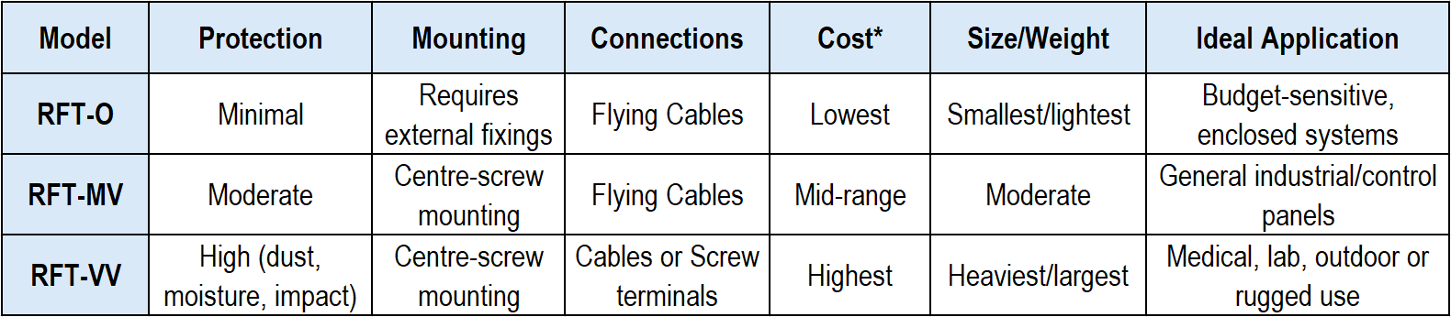
*This is a generalisation as described in the article; other factors can also determine the price of the transformer, as well as the total installed cost and lifetime cost.

Conclusion
When specifying toroidal transformers, the choice between RFT-O, RFT-MV, and RFT-VV should be guided by a clear understanding of the installation environment, regulatory requirements, and mechanical constraints. Specifiers should consider not only electrical parameters but also the total cost of ownership — including ease of installation, reliability under stress, and the potential for long-term maintenance.

Ends: 731 words

Editor’s note: If you want to ensure you keep up to date with press material, opinion focused blog content and case studies from REO UK, you can visit their news page: http://www.reo.co.uk/news

For further information or Press Enquiries contact: Steve Hughes or Michelle Gillam
REO (UK) Ltd, Units 2-4 Callow Hill Road, Craven Arms Business Park,
Craven Arms, Shropshire, SY7 8NT
Telephone: +44 (0)1588 673411
Fax: +44 (0)1588 672718
www: http://www.reo.co.uk
e-mail: marketing@reo.co.uk
Twitter: https://twitter.com/REO_UK
Facebook: http://www.facebook.com/pages/REO-UK-Ltd/263330563768795

About REO: REO specialises in providing an extensive array of electronic power controllers and resistive and inductive wound components tailored for industrial use, particularly in demanding environments. As the company expands its footprint in renewable energy technology, ensuring exceptional power quality has become a paramount focus. With manufacturing facilities in Germany, the US, China, and India, REO stands at the forefront of innovation across the globe.

