REOMED Medical Isolation Transformers: Certified Safety, Smarter Costs, and Long-Term Flexibility
In healthcare, electrical safety is critical — but so too is long-term value. As hospitals increasingly digitise and modernise their equipment, the challenge lies in balancing capital expenditure, safety compliance, and operational flexibility. REOMED medical isolation transformers, designed and manufactured by REO, offer a compelling answer: robust patient protection, independently certified compliance to the latest standards, and significant lifecycle cost savings over more integrated alternatives.

A More Cost-Effective Approach to Medical Electrical Safety
REOMED isolation transformers deliver true galvanic isolation, protecting both patients and equipment by preventing leakage currents from the mains supply — a requirement in many medical environments. A typical hospital application might include the installation of a REOMED transformer on a mobile clinical workstation, where it provides electrical safety for devices such as vital signs monitors, ultrasound machines, or bedside PCs. These units ensure continuous, compliant operation even when the equipment is moved between wards or connected to different power circuits.
Over a typical 10-year operating period, REOMED solutions can reduce costs by more than half compared to alternatives:

Configuration | 10-Year Cost (Est.) | Notes
REOMED + Standard PC | £1,150 | Low-cost PC + long-lasting isolation
Medical-grade UPS + Standard PC | £2,600 | UPS battery replacements add cost
Medical-grade PC (replaced once) | £3,350 | High upfront cost + inevitable refresh

Transferable Across Devices
Perhaps one of REOMED’s most underappreciated strengths is its device independence. Unlike an integrated solution, the transformer is not locked to a single piece of equipment. A REOMED unit can easily be repurposed as workstations are upgraded or replaced, extending its value over multiple hardware cycles.
Can any PC last 10 years? Not likely. But a REOMED transformer can — and will — continue operating safely even as the associated devices evolve. This makes it ideal for Trusts seeking to standardise safety across wards while managing budgets and avoiding unnecessary waste.

Now Fully Certified to EN 60601-1 Edition 3.2
In addition to its practical benefits, the REOMED range is fully compliant with EN 60601-1 Edition 3.2 — the latest evolution of the international medical electrical safety standard. This updated version, which came into effect in late 2023, includes more stringent requirements for insulation coordination, leakage current limits, and documentation traceability.
REOMED’s compliance ensures:
- Reinforced insulation and earth fault protection
- Leakage currents well below critical thresholds
- Verified component safety under fault conditions
- Clear documentation to support MHRA, UKCA, and CE audits

Built for Demanding Clinical Environments
REOMED units are compact, passively cooled, and suitable for floor, wall, rack, or DIN-rail mounting. They are available in power ratings from 300 VA to 2.2 kVA, making them ideal for:
- Anaesthesia machines and ventilators
- Imaging equipment (X-ray, CT, MRI)
- PACS and clinical workstations
- Bedside monitors and patient trolleys
- Any application where leakage currents must be limited
They are particularly well-suited to mobile and modular applications, where built-in PC-based isolation is neither practical nor sustainable.

Summary: Safety Without Compromise

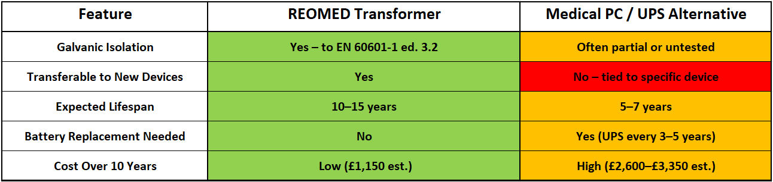

The NHS continues to face pressure to do more with less, solutions like REOMED offer a clear way forward — combining certified compliance, flexible deployment, and long-term savings without compromising on patient safety.

Ends: 523 words

Editor’s note: If you want to ensure you keep up to date with press material, opinion focused blog content and case studies from REO UK, you can visit their news page: http://www.reo.co.uk/news

For further information or Press Enquiries contact: Steve Hughes or Michelle Gillam
REO (UK) Ltd, Units 2-4 Callow Hill Road, Craven Arms Business Park,
Craven Arms, Shropshire, SY7 8NT
Telephone: +44 (0)1588 673411
Fax: +44 (0)1588 672718
www: http://www.reo.co.uk
e-mail: marketing@reo.co.uk
Twitter: https://twitter.com/REO_UK
Facebook: http://www.facebook.com/pages/REO-UK-Ltd/263330563768795

About REO: REO specialises in providing an extensive array of electronic power controllers and resistive and inductive wound components tailored for industrial use, particularly in demanding environments. As the company expands its footprint in renewable energy technology, ensuring exceptional power quality has become a paramount focus. With manufacturing facilities in Germany, the US, China, and India, REO stands at the forefront of innovation across the globe.

